About Me:
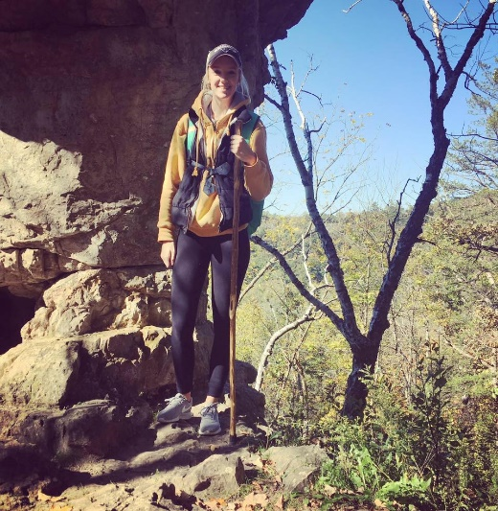
Ms. Olson
My name is Ms. Olson and I am currently a senior at Winona State University-Rochester and I will be joining Mrs. Offen in the classroom over the next few months. I am so excited to get to know everyone and we are going to have so much fun learning and exploring together. To get to know me a little better, here are a few of my favorite things…

My Favorites

Color: Turquoise
TV Show: Gilmore Girls
Food: Tacos
Hobby: Spending time outdoors
Season: Fall
Candy: Recess/Fastbreak
Education
I am currently a Winona State University- Rochester senior in the Elementary Education program. I will graduate with my teaching degree in the spring of 2018.

Contact

CMOlson12@winona.edu

